Assignment -4
Wokwi Programming

Assignment Date | 29 October 2022
Student Name | L.Muthukamatchi
Student Roll Number | 912419106005
Maximum Marks | 2 Marks

Question-1:

Write code and connections in wokwi for ultrasonic sensor.
Whenever distance is less than 100 cms send "alert" to ibm cloud and display in device recent events.
Upload document with wokwi share link and images of ibm cloud.

Solution:
Coding:-

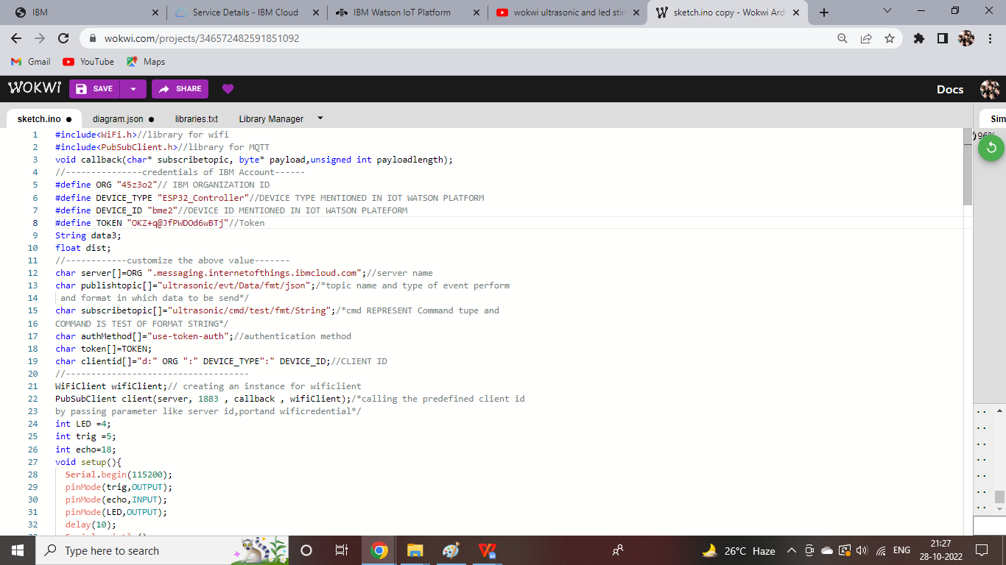

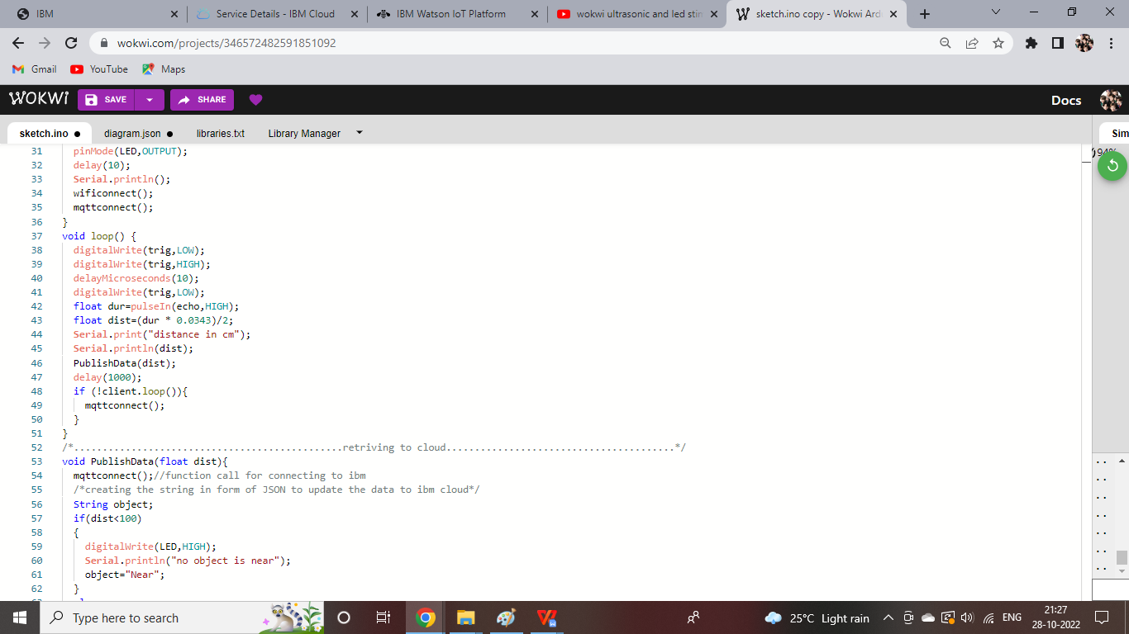

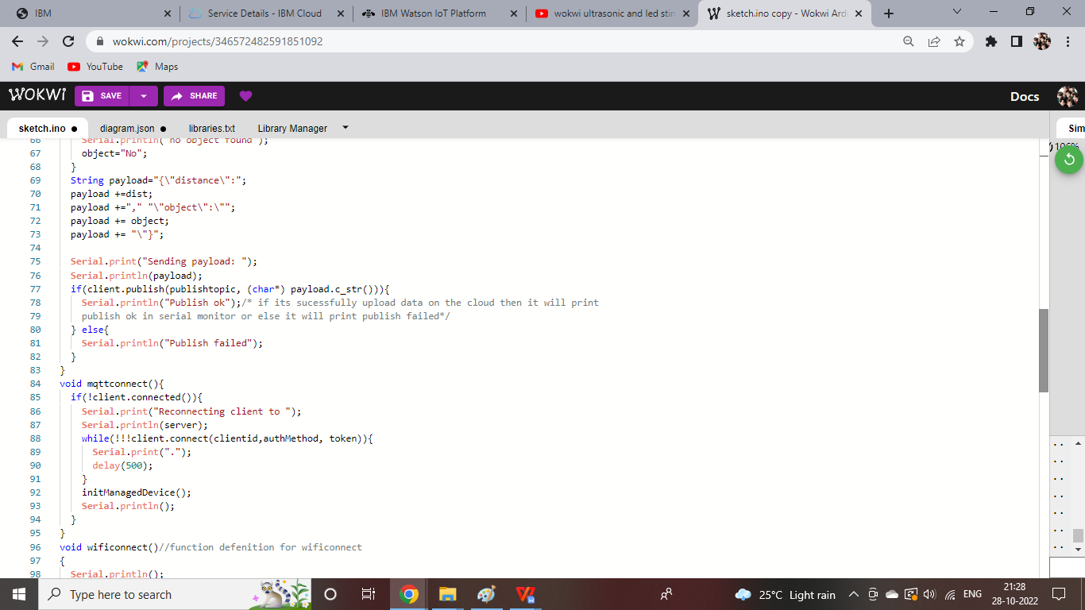

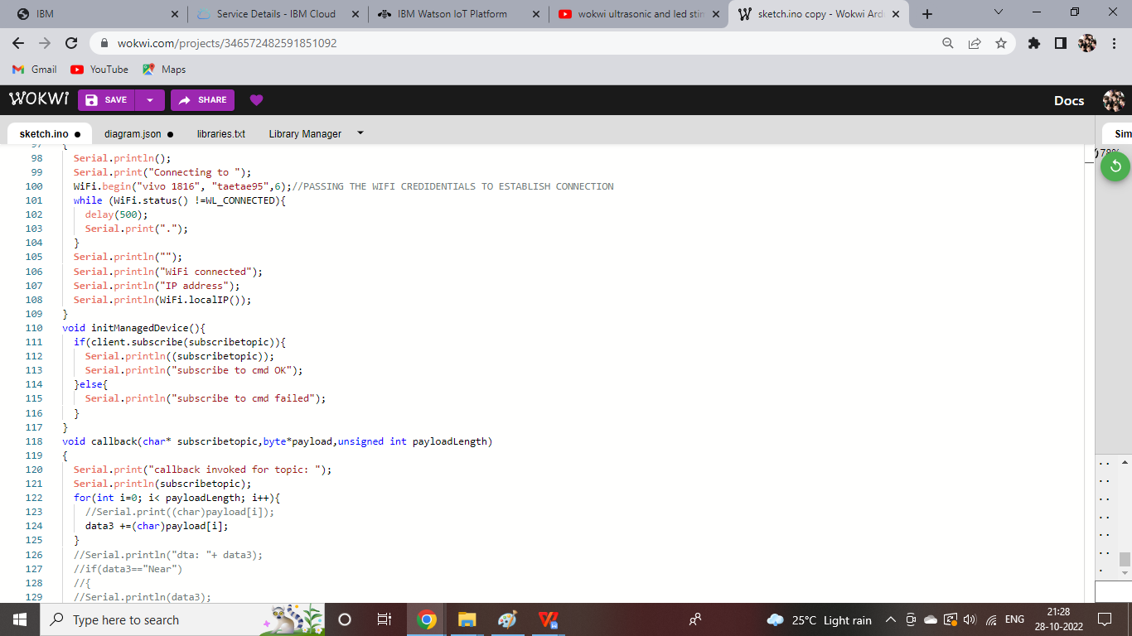

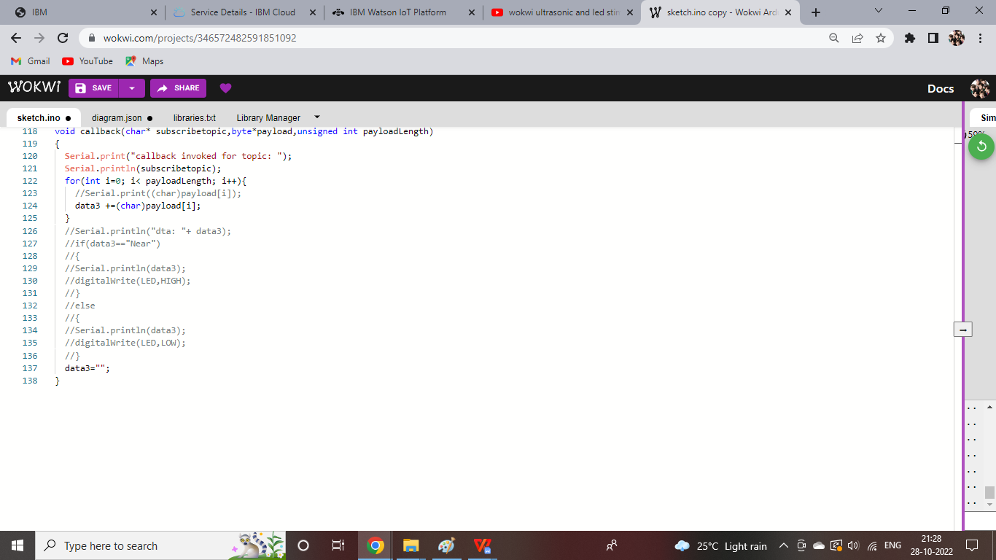
DATA SENT TO IBM CLOUD ON NO OBJECT DETECTED
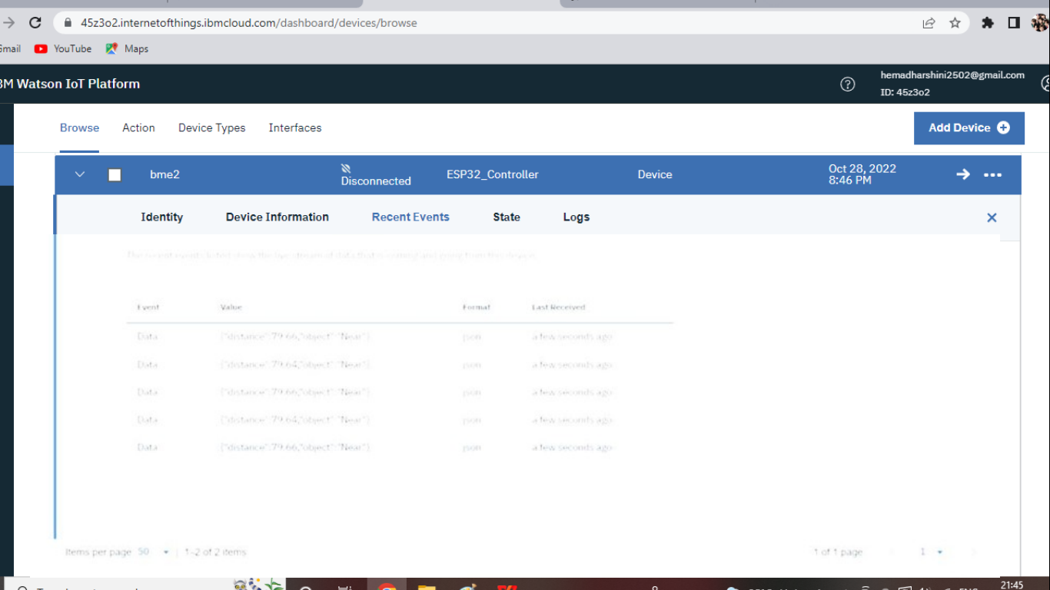
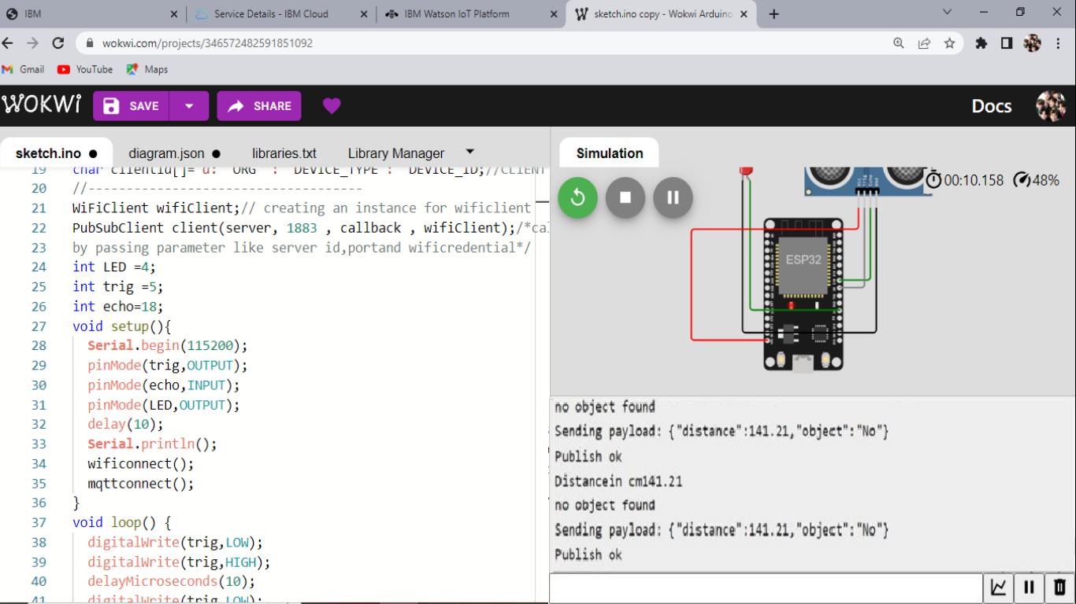
DATA SENT TO IBM CLOUD ON OBJECT BEING DETECTED

